

A CLASS ABOVE

Gorbel® Solutions Moving Pumps at Liberty Pumps and Expanding Facility

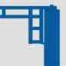

Industry:

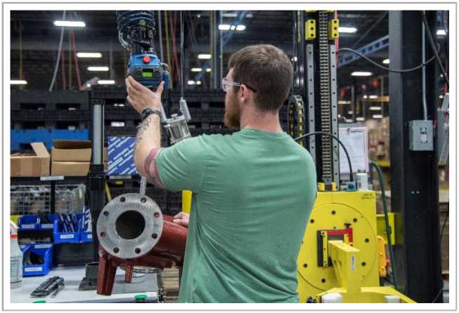

Pumping Products Manufacturer

Product:

Groundwater and Wastewater Removal Products

The Problem:

Multiple needs for overhead lifting capabilities

The Solution:

Gorbel® Work Station Cranes, Jib Cranes, and G-Force

**Quality Solutions for Pumping Products Manufacturer**

Liberty Pumps, headquartered in Bergen, NY, is a leading US manufacturer of Pumping products. For groundwater and wastewater removal in residential and commercial applications. With a focus on innovative product design, Liberty Pumps wide range of pump styles include sump pumps, sewage pumps, drain pumps, grinder pumps, complete pre-assembled sewage packages and pump accessories.

Over the years, Liberty Pumps has come to Gorbel® for a number of material handling solutions. "We started out years ago, we got our first Gorbel® crane," said Randy Waldron, Vice President of Sales & Marketing. "The products are good quality and they work and they seem to keep coming up with solutions as we grow they come out with new products, our products get more complex. We need ways to provide a safe work environment for our employees to handle these products and they always seem to come up with a good solution for. It's surprising how many different areas in the company we use that product. It makes life easier for our employees and it makes it safer."

Gorbel® systems are throughout the Liberty Pumps facility, from the machine shop, to the paint line, to the areas of assembly. The engineered pump systems department also uses the overhead crane system. "The Gorbel system definitely makes it easier to lift some of the heavy

parts here at Liberty Pumps," said Michael O'Connor, Machine Shop Team Leader. "Some of them weigh as much as 60-70 lbs., so lifting those all day using the Gorbel® system definitely helps making my job much easier."

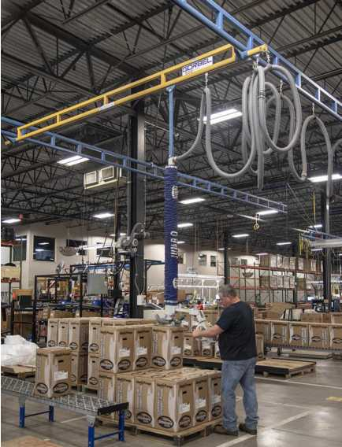

A CLASS ABOVE

Liberty Pump uses Gorbel® Work Station Cranes, Jib Cranes and G-Force® throughout the facility, allowing workers to get their job done safer and more efficiently. "The weld construction with the enclosed track and how well the bridges move without wanting to bind and get off track from side to side on long spans, I think it's the best in the industry," said Don Cunningham, Manufacturing Manager. "The G-Force® product is very innovative and very effective in certain applications. It's a well-received, well-liked product."

High quality products need high quality solutions, which makes Liberty Pumps and Gorbel® a great pair. "We produce very high quality products, ones that provide solutions for customers and I think Gorbel® does the exact same thing. Their products are very high quality. I think that's a real similarity between our two companies," said Waldron.